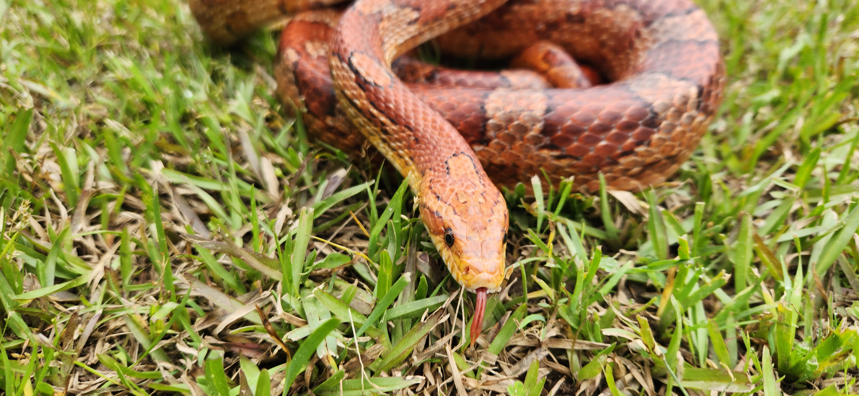  April 22nd  @ 6:30p  Snakes!!  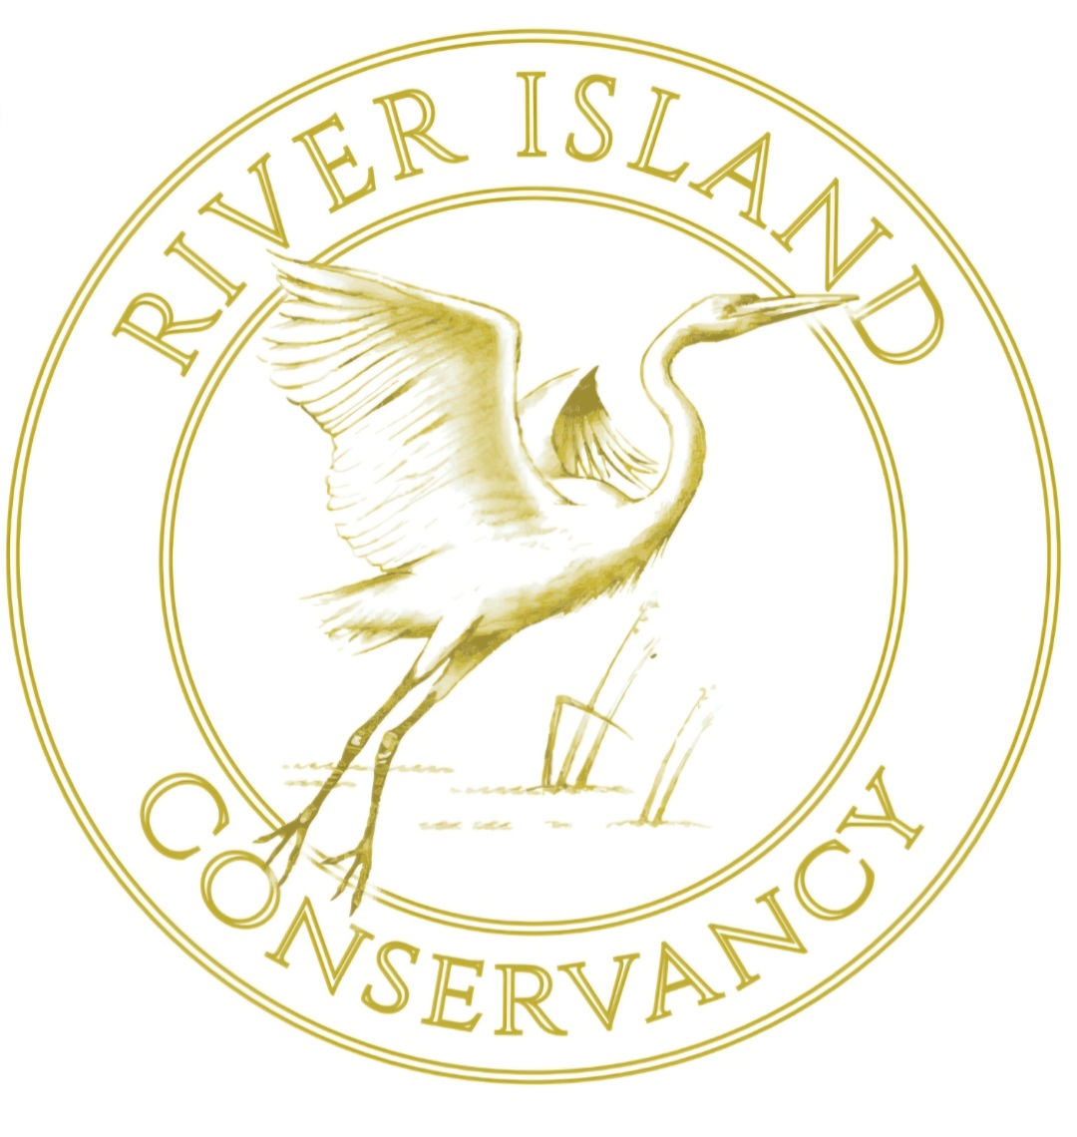Join your neighbors at the River Island Pool House for a presentation regarding the snakes of the CSRA. You will learn all about local snakes and be able to see live animals as well. This session is limited to adults over 18. Please register in advance for appropriate seating to be made available. | For adults over 18  ────  Presented by experts from Reed Creek Park  ────  Find out why we protect snakes  ────  Learn the difference between venomous and non-venomous  ────  Live animals!  Presented by the river island conservancy  riconservancy.com  Registration:  kristivjohnston@gmail.com

